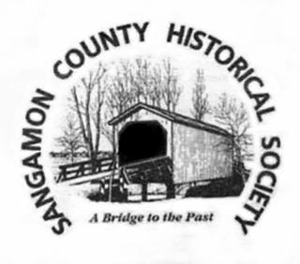
2024 Sangamon County Historical Society Grant Application

Date: ___________________________
Name: ______________________________________________________________________
Organization Name: _____________________________________________________________________________
Address: _____________________________________________________________________
City, Zip: ____________________________________________________________________
Phone: _____________________________ e-mail address: ___________________________
(Please use Word Doc. & use additional pages as necessary)
TITLE OF PROJECT:

DESCRIPTION OF THE PROJECT: Please describe the proposed project and explain how it relates to the specific mission of the Sangamon County Historical Society to “preserve and promote the history of Springfield and Sangamon County.” Note: The Society generally does not provide funds for books, private events, paying volunteers, or advertising. The Society will prioritize projects with permanence. Please provide specific details when describing your project’s goals.

AUDIENCE FOR THE PROJECT: Who is the audience for this project? Who will find the project most interesting and valuable? Who will benefit from your project’s grant.

-2-
PROJECT BUDGET: SCHS is offering individuals and organizations grants up to $1,000. Please state the overall budget for your project, how much money you are asking for from SCHS, and what specific components of the project the grant money will be used for. Please be as specific as possible when discussing budget allocations (i.e. detailed line-item proposal costs).

TIMELINE FOR THE PROJECT: Projects must be initiated after July 1, 2024 and completed by June 30, 2025 to be eligible. Please detail when your project will begin and when it will be completed.

THE REQUESTING ORGANIZATION OR INDIVIDUAL: Please provide the name, address, phone number, email address, and all relevant experience of the project manager. For group applications, please also include the mission statement for your organization.

ASSURANCES IN THE APPLICATION: If (I/we) are awarded a grant, (I/we) agree to publicly recognize the Society’s assistance and, on a schedule set by the Society, will periodically provide progress reports to the SCHS Board of Directors. Any funds not spent for the project will be returned to the Society. Please indicate how the SCHS will be recognized by your organization. Please provide photos of the completed project to SCHS.

____________________________________________________
Applicant’s Name/ or Organization authorized signature and title
Send the completed form by the deadline by e-mail to grants@sancohis.org or by regular mail to Sangamon County Historical Society/Special Projects Committee, Box 9744, Springfield, IL 62791-9744. Applications must be received by April 20, 2024.

